Achievements –
Faculty Achievements:-
- Manual is prepared for experiments.
- Inspire students for taking initiatives in Plantation.
- Inspire student to make low cost instrument.
- Create the interest in physics through drama, quiz etc.
- Completed six certificate courses from IIT Kanpur and VPTEL.
- Prepared move than 2000 sapling with the help of ladies in rural area.
- Member in board of studies.
- Conduct Energy Audit in the Campus with a view to sensitize the efficient energy
- Encourage students to design solar assisted sell assembled gadgets.

Swachh Bharat Abhiyan in village Kundru in 2017
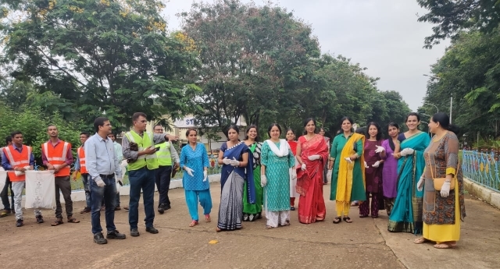
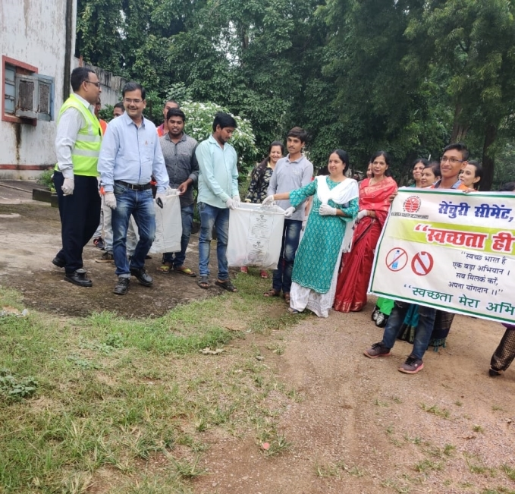

Prize distribution in village Kundru in 2017
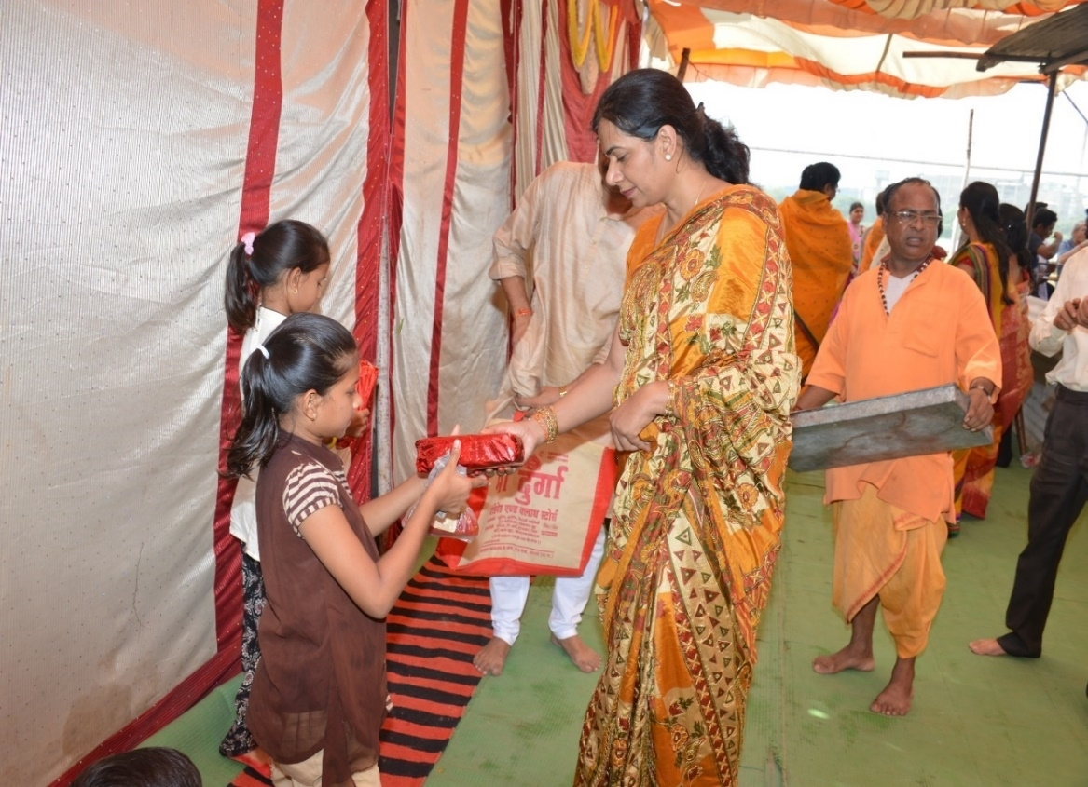

Encourage art and craft of village women in 2018
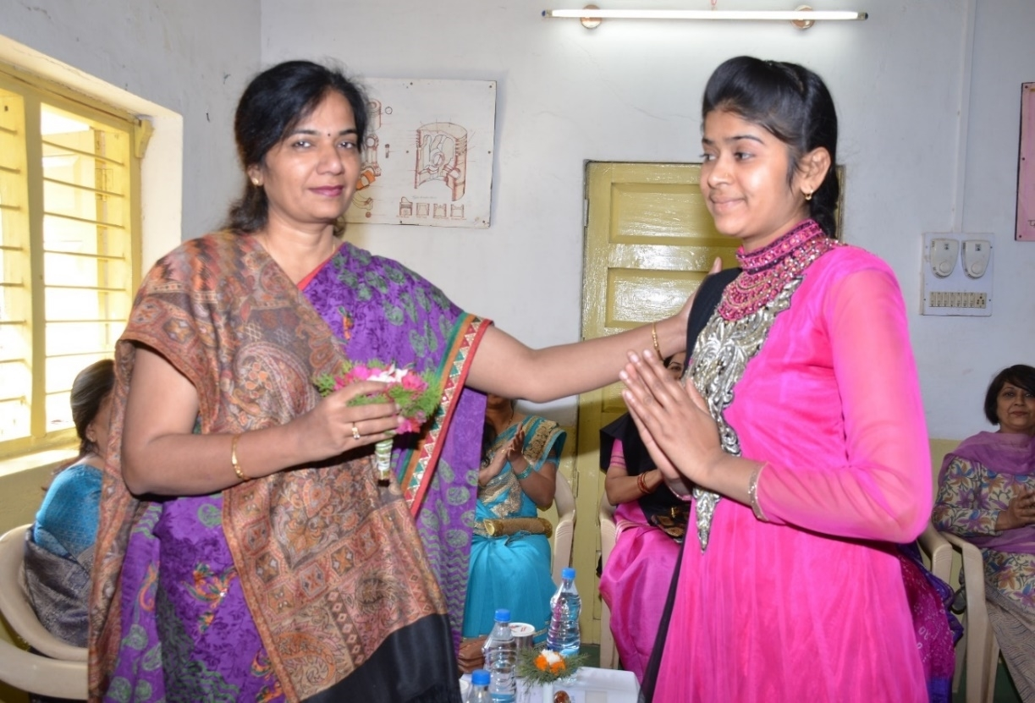
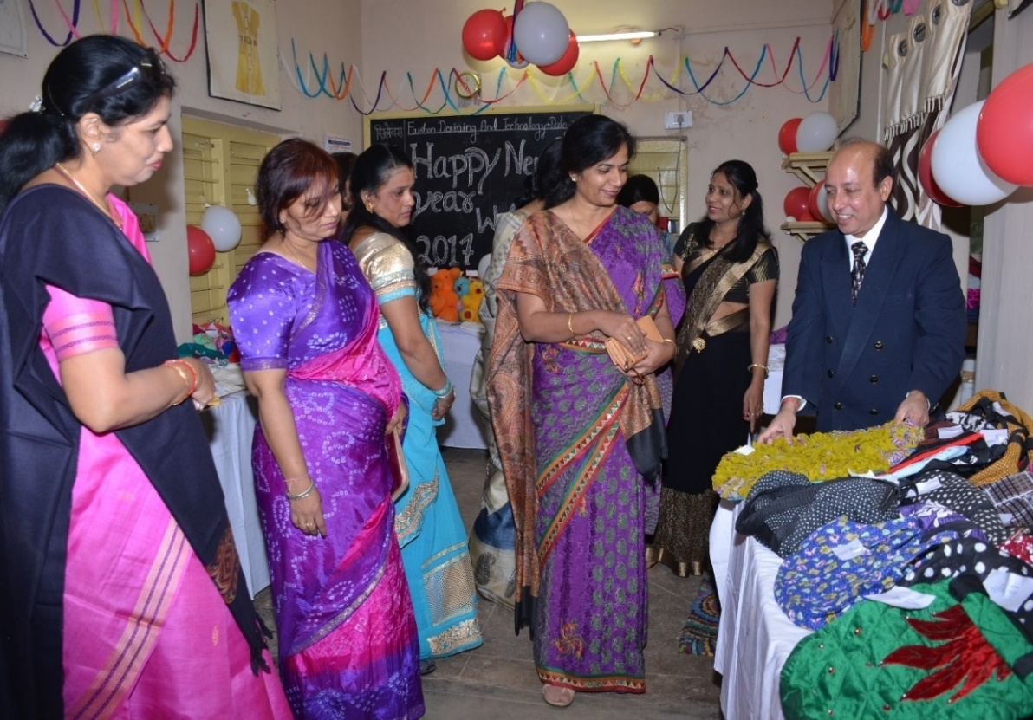

Tailoring classes in village Kundru in 2018

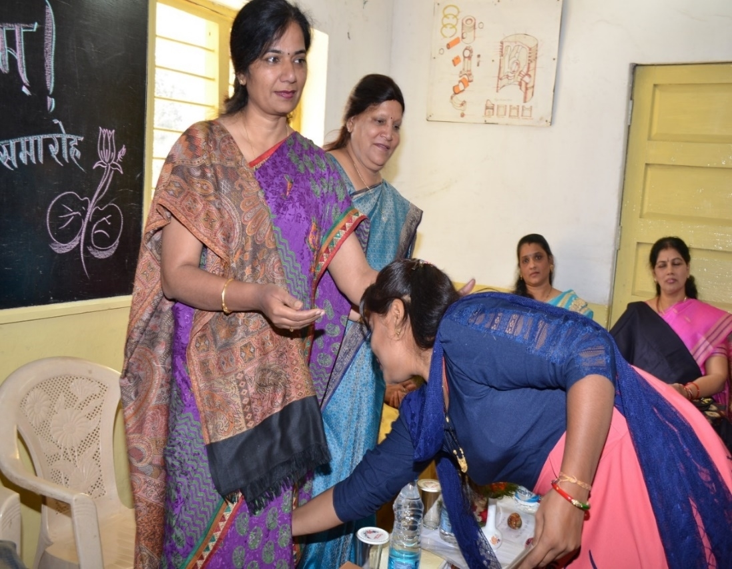
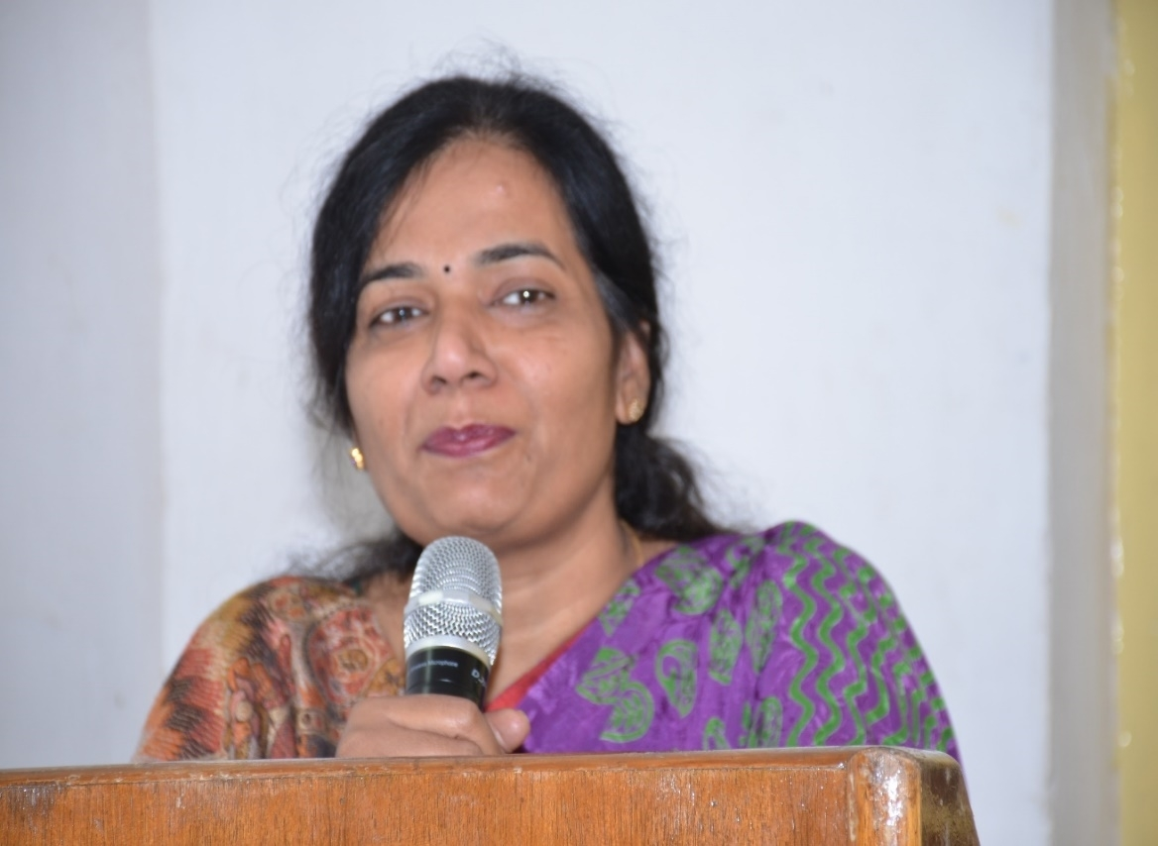

Plantation on environment day in June 2019

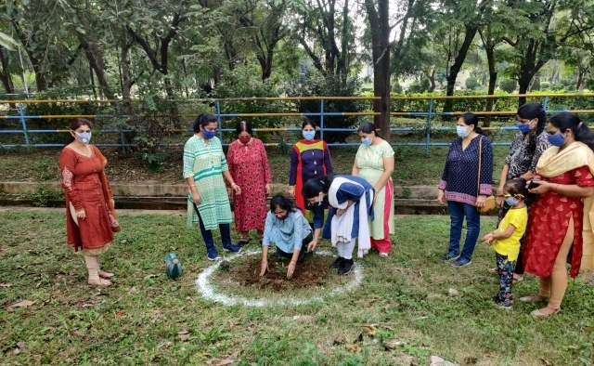
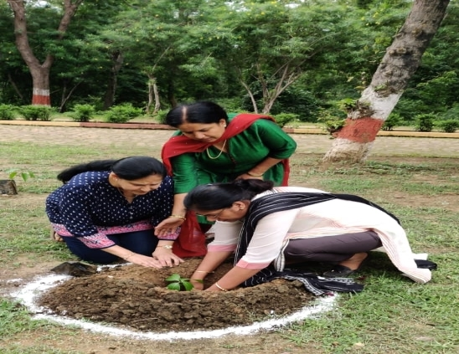

Support to old age home in January 2019
